

Development Android

David LUONG  
C00221536

Web application

computer system management year 3

24 février 2017

Table des matières

**Aucune entrée de table des matières n'a été trouvée.**

# Introduction

The third and last assignment of Web Application is the development of an Android application. This application will be my Resume.

You will have the possibility to find below, which tools I decided to use and why this tools and not another one.

My principal objective has been to develop a flat design application and easy to use.

# Selection of the tools

To do this application, I had few option. You will find the different option below and they pros and cons.

Android Studio

|  |  |
| --- | --- |
| Pros | Cons |
| Officiel IDE of Android | Gradle can be very long |
| Layout view & XLM on same screen |  |
| Drag & drop |  |
| Support of community |  |

Eclipse

|  |  |
| --- | --- |
| Pros | Cons |
| More stable than Android Studio |  |
|  |  |
|  |  |
|  |  |

Buildfire

|  |  |
| --- | --- |
| Pros | Cons |
| Easy to use | Dependent on internet |
| Usefull for people who have no knowledge in coding | Codeless |
| Templates integrate | Paid option |
| Codeless |  |

# My choice

1. Android Studio

I decided to choose Android Studio instead of Buildire. I Could use Eclipse, however I prefer to have the official tools Android, in case of update of library of something else.  
Why? Because to me, those web tools is not really a Development Android, you just have to type your text and that’s all. It is not really development, it is just codeless.

With Android Studio, you built your app from nothing. It is a real development.

1. Java

To do the features, I used java.

1. XML

The XML will be used for the designing of the layout. All pages will have his own layout.

1. Computer

I decided to work on my own personal computer. Thanks to this choice, I had more flexibility and more possibility instead of using a computer at the IT.

You will find bellow the configuration on my Pc to run Android Studio.

CPU: Intel core i7 6700HQ (4 cores, 4 threats, 2,6GHz up to 3,5GHz)  
GPU: GTX 960M  
RAM: 8go DDR4  
HDD: 1To  
SDD: 250go Crucial  
OS: Windows 10 Professional

1. Phone

To check the application during the development, I used the virtual phone of Android studio, but also my personal phone.

To me we don’t feel the mobile application on the virtual phone, you should have the application in the hand to see if it is intuitive and easy to use. It is like if you read a book in paper and the book in e-book version, you will not feel the same because with the e-book it is not really a book. Instead of the version paper it Is different. So, it’s the same with the mobile application.

CPU: Kirin 935 (Octa-Core 2.2GHz)  
GPU: Mali-T628 MP4  
RAM: 3go  
HDD: 16go Samsung  
SD Card: 64go Toshiba  
OS: Android 6.0 Marshmallow

# Screenshot & Development

Changement of the icons of the App –



Welcome Screen -MainActivity

When we open the application, before to be on the home screen, we will have a WebcomeScreen with the title of the application and few details.

HomeScreen –

The home screen will contain the different part of the curriculum vitae, the user will decide wich section he wants to see.

Personal detail –

This parts contain my personal detail and a redirection link to my LinkedIn profile.

Education History –

For this part, I used a tabbed activity to separate each degree.

Employment history –

For this part, I used a tabbed activity to separate each employment history.

Interest & Hobbies –

For this part, I used a tabbed activity, to see each interest or hobbies, you have to slide on the right or on the left.

Skills –

For this part, I used a tabbed activity to have sub division for the skills. (Computing, Language and others)

References –

For this part, I used an empty activity. I just put few textView to show few details of the people.

Project work –

For this part, I used an empty activity, the objective is just to show my future project.

About –

This part was optional, this part is just to show the “Why” and “Who”, the application.

# Backup of the Project

To back up my project, I decided to use GitHub. Thanks to this utility tools I have a view of all progress of my project and every modification I did.

For each progress in the project, I use these command in my command prompt GitShell :

Git status: Check which files has been modifying or added to the project

Git add.: Update the index with all files modify or created

Git commit: Add the modify, created files to the local repository.

Git push origin master: This command sends all the modify to the remote repository.

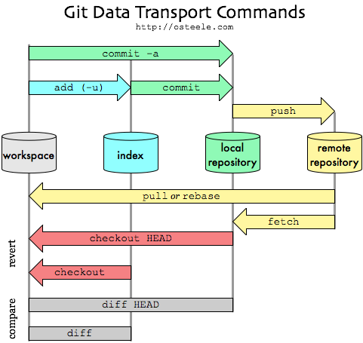

Normally, I shouldn’t work on the Master branch. The master branch is the main line of the project. But in my case, I can work on the master branch because I am alone on the project.

If we were in team in the project each members of the group should create on his own branch and work on it. And when someone finish his features, he can push on master.

You can see the following schema bellow. If few people modify on the same file, when we push on master branch, we will have the choice to delete one part the code or keep it.

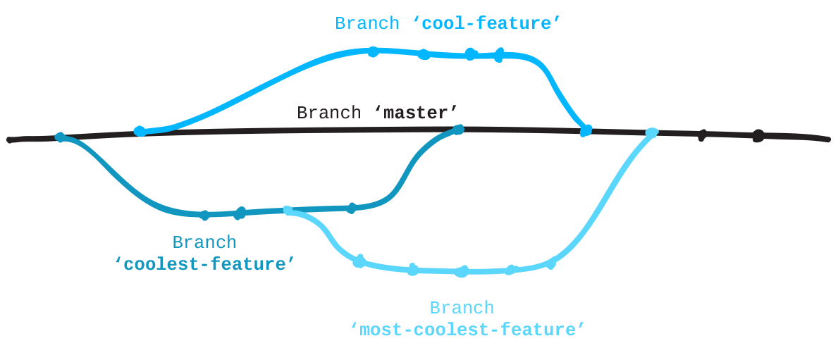

GitHub is a very powerful tools, it is like SVN however after use, I personally prefer GitHub that’s why I decided to use it to back up my project and I will re-use it for the next project.

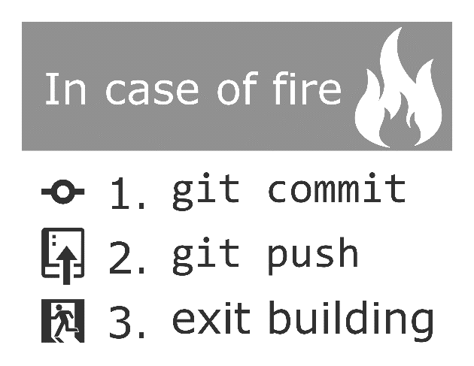

You have the possibility to download the project to this link:

<https://github.com/c00221536/WebAppAndroid>

# Problems

1. Design

I really want something simply and beautiful. That’s why I decided to focus my design on the Flat design. As we can see on the application, we have simple colors and minimalist.

1. Code

About the development, I had few problems to solve, to solve it I was looking on **StackOverflow**. The Android community is important and active. It wasn’t difficult to find solutions to my problems.

However, I have one problem about the development and I wasn’t able to simplify it. The problem was the change de default font for the whole app, I am totally sure it was possible to simplify how I did it. Currently for each activity page, I was looking for each TextView and I setFont and I assign the new font.

I didn’t find an another way to simplify this.

# Conclusion

This assignment was really appreciating. The app will be useful for the recruiter when we will do some interview. It is really something who can be useful.

I really enjoying developing this application. However, if I could show it to an recruiter, I don’t know if I will. If I have to show my curriculum vitae in mobile version I will do a another application